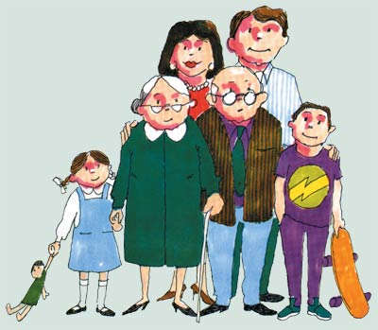
SCHOOL

Name: ________________________Class: _______ Number:_______

Family / Possessive case “’s” :
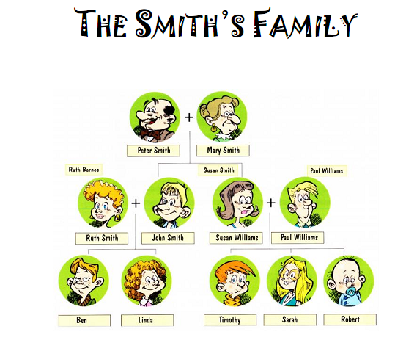
1. Look at the picture.

  - Write True (T) or False (F)
about the Smith’s family.

- Peter is Sarah’s father.
- Ruth is Robert’s aunt.
- Linda is Timothy’s cousin.
- Paul is Ben’s father.
- Susan is Linda’s grandmother.
- Mary is Robert’s aunt.

1.2. Correct the false ones.

- __________________________________________________________________
- __________________________________________________________________
- __________________________________________________________________
- ___________________________________________________________________
- ___________________________________________________________________
- ___________________________________________________________________

  - Complete the sentences.
a) Linda is ________________ sister. b) Mary is _____________ mother.
c) Susan is _____________ aunt. d) Paul is ______________ father.
e) Ben is ______________ cousin. f) Peter is _____________ father.

1.4. Replace the nouns by the correct pronouns.
Ex.1: Susan is Sarah’s aunt. Ex.2: Peter is Susan’s father.
She is Sarah’s aunt. He is Susan’s father.

a) Peter is Linda’s grandfather. b) Mary is John’s mother.
____________________________________ ____________________________________

c) Paul is Robert’s father. d) Mary is Timothy’s grandmother.
____________________________________ ____________________________________
1.5. Translate the sentences.

a) ___________________________________ b) _____________________________
c) ___________________________________ d) _____________________________

2. Answer the questions.

a) Is Ben Linda’s brother? b) Is Paul Ben’s father?

Yes, she is. No, she isn’t. Yes, she is. No, she isn’t.
Yes, he is. No, he isn’t. Yes, he is. No, he isn’t.

c) Is Susan Linda’s aunt? d) Is Ruth Ben’s mother?

Yes, she is. No, she isn’t. Yes, she is. No, she isn’t.
Yes, he is. No, he isn’t. Yes, he is. No, he isn’t.

