English

Name: _______________________________________________ Date: ____________________

- Read the text:

Pirates

Jack Sparrow is a pirate. His friends are pirates too. Jack and his friends studied a treasure map. They wanted to find gold coins.
They found a treasure chest. It was buried under a tree.
They carried the treasure to their pirate ship.
Jack tried to open the lock on the treasure chest. The pirates were worried Jack could not open the lock. Jack finally opened the treasure chest.
There were many gold coins inside the treasure chest.

- Answer the questions.
a) What did the pirates find buried under a tree?
___________________________________________________________________________
b) Did Jack Sparrow open the treasure chest?
___________________________________________________________________________
c) What was inside the treasure chest?
___________________________________________________________________________

- Write the Past Simple of the verbs.
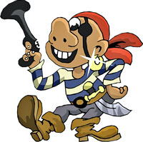
a) The Pirates __________________________ (bury) a treasure.
b) Jack Sparrow and the other pirates _________________________ (carry) the treasure chest.
c) They were ________________________ (worry) about the lock on the treasure chest.
d) Jack _________________________ (try) to open the treasure chest.

