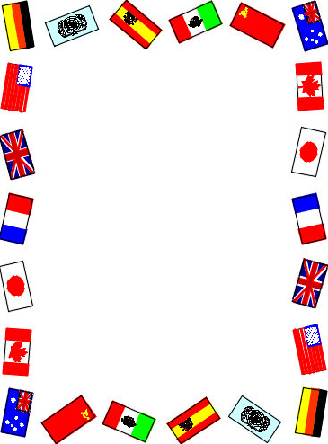

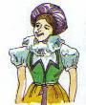


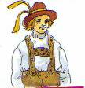


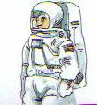
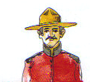

I´m from Germany, I´m German...
He is from Germany. He is German.
She is from Portugal. She __________________.
She is from _________. She is Austrian.
She is from Brazil. She ____________________.
He is from __________. He is American.
She is from __________. She is Angolan.
he is from___________. He is Spanish.
He is from Canada. He ___________________.
He is from Australia. He __________________.
She is from ___________. She is Swedish.

1
2
3
4
5
6
7
8
9
10
Countries and Nationalities
My name is Teresa. I'm twenty-nine years old.
I come from Brazil. My nationality is Brazilian.
I can speak Portuguese and a little English.
I am studying English at college.
I live in England with my husband and our son.
My mother and my father live in Brazil.

Answer the questions below. Tick (✓) one box for each question.
1. Where does Teresa come from?
England  
Brazil  
Portugal  
2. What is Teresa studying at college?
Portuguese  
English  
Brazilian  
3. What is her nationality?
Brazilian  
English  
Portuguese 

Now answer:

- Where is Teresa from?
_____________________________________________________.

- What is her nationality?
_______________________________________________________.

- Where does she live?
_______________________________________________________.

