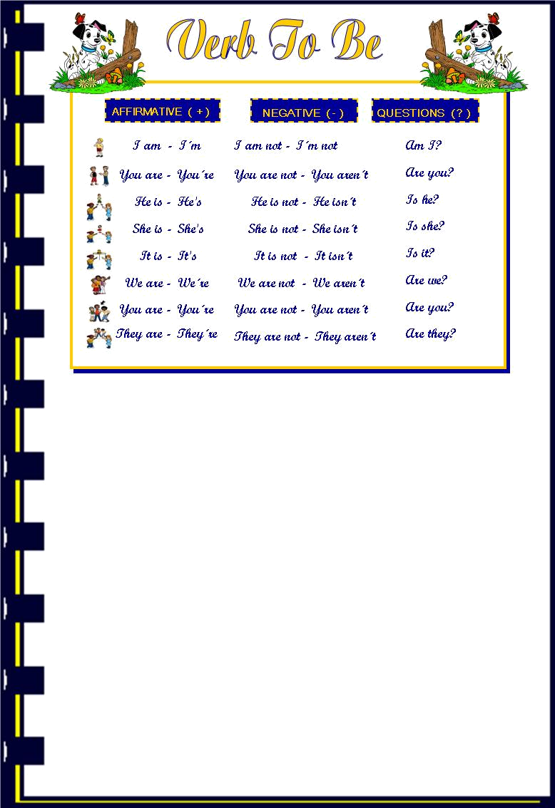
- Find the correct answer:

- Are you French?
- Yes, I am.
- Yes, she is.
- No, it isn´t.

- Is Mark your brother?
- No, we aren´t.
- Yes, he is.
- Yes, she is.

- Are the students in the classroom?
- Yes, he is.
- No, they aren´t
- Yes, I am.

- Is the school open?
- Yes, she is.
- Yes, it is.
- No they aren´t

- Are the girls at home?
- Yes it is
- No, it isn´t
- Yes, they are.
B) Rewrite the sentences. Use the short form.
- It is a pencil case.
- ____________________________
- We are friends.
- ____________________________
- He is American.
- ____________________________
- They are dirty.
- ____________________________
- I am a good student.
- ____________________________

C) Complete the sentences with am, is or are.

- He ________ Portuguese.
- This _________ my dog, Thunder!
- They _________ twelve.
- These _________ my friends.
- I _________ tall.
- Susan _________ my best friend.
- Mary and Jane _________ teachers.
- You and I _________ students.
- The class _________ small.
- We _________ cousins.

D) Make negative sentences:

- Mary is twelve years old
- _______________________________________________
- I´m a student.
- _______________________________________________
- They are Portuguese.
- _______________________________________________
- My phone number is 8301414
- _______________________________________________
- He is my best friend.
- _______________________________________________
- We are friends
- _______________________________________________
- Mark and Mary are twins
- _______________________________________________
- You are a teacher.
- _______________________________________________
- Mark is tall.
- _______________________________________________
- They are noisy students.
- _______________________________________________
- It is a blue book.
- _______________________________________________

E) Make these sentences interrogative.

- You are my cousin.
- _______________________________________________
- I´m your English teacher.
- _______________________________________________
- Mary and Ann are twelve years old.
- _______________________________________________
- It´s a pencil case.
- _______________________________________________
- We are intelligent.
- _______________________________________________
- I am beautiful
- _______________________________________________
- They are at school
- _______________________________________________
- Rose and I are Portuguese.
- _______________________________________________
- It is a dog.
- _______________________________________________
- You are ten today.
- _______________________________________________
- Mark and Ann are brother and sister.
- _______________________________________________

F) Complete the sentences as the example.

- They are doctors (✓) , They aren´t singers. (✗)
- I ______ number tree (✓). I _______ number two. (✗)
- He ________ thirteen years old. (✓) He _________ Twelve years old (✗)
- You _________ nice (✓). You _________ stupid (✗)
- We ________ from Portugal (✓). We __________ from France. (✗)

G) Put the words in the correct order:

- Am / I / a / teacher
- ______________________________________________
- Not / an / engineer / he / is
- _______________________________________________
- Your / number / fifteen / is / room
- _______________________________________________
- Doctor / are / you / ? / a
- _______________________________________________
- Number / room / your / thirteen / ? is
- _______________________________________________
- Is / not / student / she / a
- _______________________________________________
- Is / good / this / book / very
- _______________________________________________
- American / David / is / friend / my
- _______________________________________________
- In / the / are / ? / you / garden
- _______________________________________________
H) Complete the questions with the correct form of verb to be, then answer the questions.

- _____________ you a boy?
- ____________________________________
- ____________ a student?
- ____________________________________
- __________ your family Portuguese?
- ____________________________________
- __________ Thunder a dog?
- ____________________________________
- __________ your mother a doctor?
- ____________________________________
- ___________ you twelve?
- ____________________________________
- __________ it nine o´clock?
- ____________________________________
- __________ your father tall?
- ____________________________________
- __________ you nice?
- ____________________________________
- _________ your partner intelligent?
- ____________________________________

- Put the words in the correct order and make questions:
- Teacher is who your ?
- _______________________________________________
- Your from where mother is ?
- _______________________________________________
- Favourite sport what your?
- _______________________________________________
- Old dog your how is ?
- _______________________________________________
- Are you who?
- _______________________________________________
- The when on programme is?
- _______________________________________________
- Pens are my where ?
- _______________________________________________
- The is what time?
- _______________________________________________
- Book is where the?
- _______________________________________________
- Your birthday is when?
- _______________________________________________

J) Make questions for these answers.

- _______________________________________________
No, I´m not American.
- _______________________________________________
They are at home.
- _______________________________________________
She is fifteen.
- _______________________________________________
I´m fine, thanks
- _______________________________________________
They are Portuguese.
- _______________________________________________
They are at school.
- _______________________________________________
Yes, they are French.
- _______________________________________________
Yes, I´m new here.
- _______________________________________________
No, we aren´t twins.
- _______________________________________________
I´m from Lisbon.

