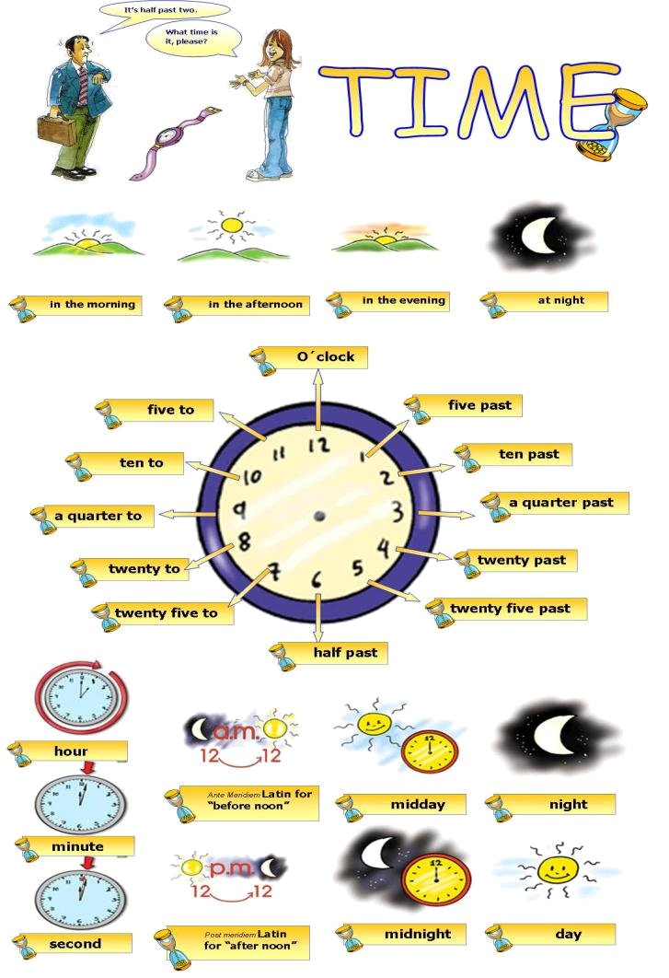

What time is it? Look at the clocks and write the time.
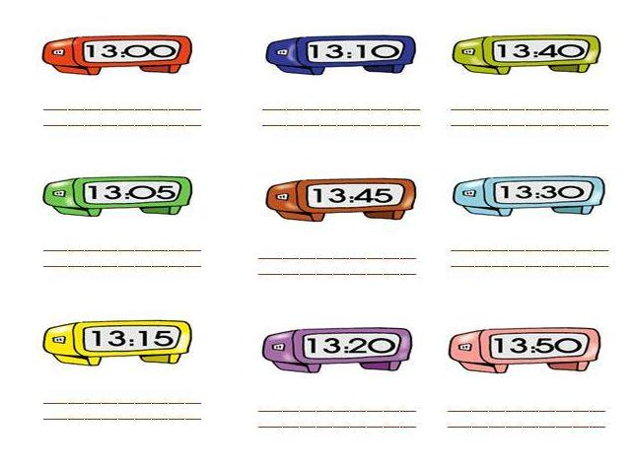

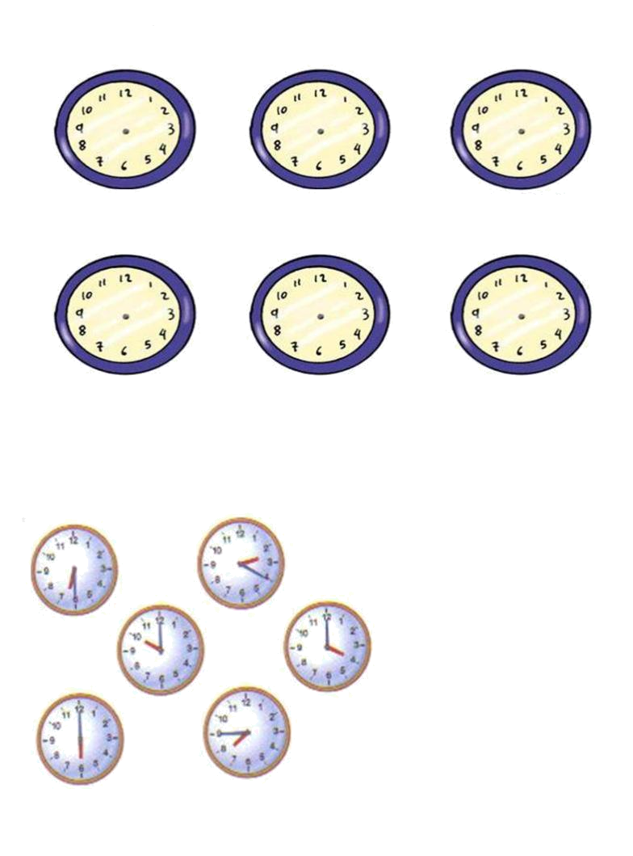
Draw the hands of the clocks.

It´s half past four.
It´s five to seven
It´s midday
It´s a quarter to ten.
It´s ten o´clock.
It´s half past five.
Match:
- It´s four o´clock.
- It´s a quarter to eight.
- It´s half past six.
- It´s twenty past two.
- It´s ten o´clock
- It´s six o´clock.

Write true sentences about yourself.

Example (wake up) – I usually wake up at seven o’clock.

- ( have breakfast) ________________________________________________
- ( get the bus) ___________________________________________________
- ( go to Scholl) ___________________________________________________
- ( Have lunch) ____________________________________________________
- ( do my homework) ________________________________________________
- (have dinner) ____________________________________________________
- (go to bed) _____________________________________________________

Write the correct preposition of time.
- I go back home __________ five o´clock.
- I go to school __________ the morning
- My father goes to work __________ midday.
- I read __________night.
- I do my homework __________ the evening.
- School begins __________ 8 a.m.
- I have lunch __________ noon at the canteen.
- I always go to bed __________ midnight.
- My dance lessons start __________ half past six.

