WHAT TIME IS IT?
Name:____________________________Date: ____ /____ /____Class: _______
Match the clocks in the first column to the right times in the second column
1) |  | a) | it is twenty-five to four
2) | 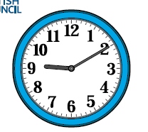 | b) | it is five past ten
3) |  | c) | it is five to twelve
4) |  | d) | it is a quarter to two
5) | 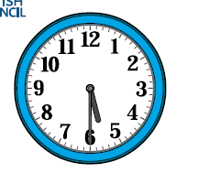 | e) | it is eleven o´clock
6) | 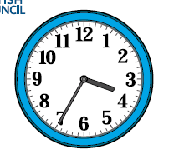 | f) | it is ten to one
7) | 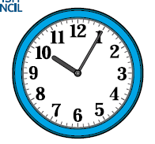 | g) | it is twenty to three
8) |  | h) | it is ten past nine
9) |  | i) | it is twenty-five past six
10) | 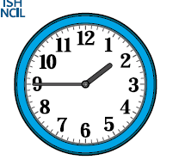 | j) | it is half past five
11) | 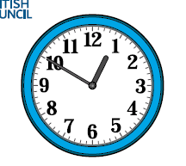 | k) | it is twenty past seven
12) |  | l) | it is a quarter past eight

