English Worksheet

Name: _________________________________ Class: ________ Date: ____/____/____

What’s the time, please?

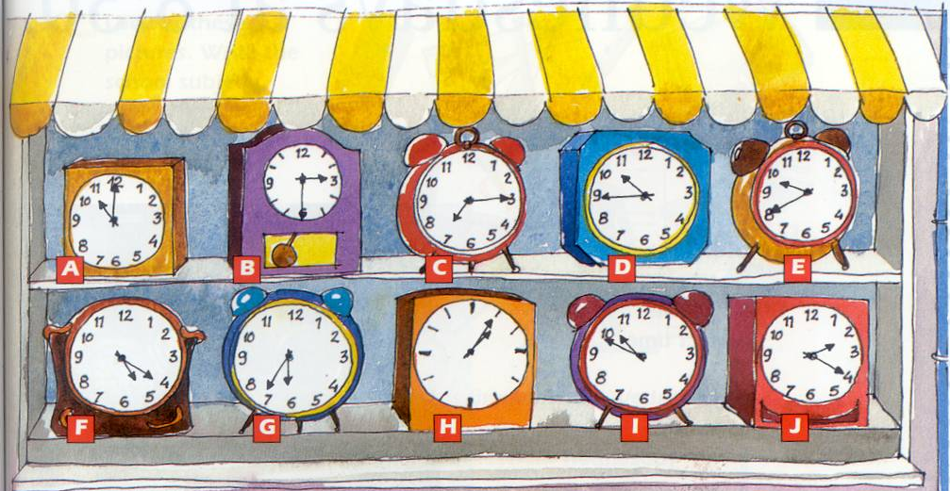
- Look at the clocks and write the correct letter on the sentences.

A | It’s eleven o’clock. |  |  | It’s half past three.
 | It’s a quarter past seven. |  |  | It’s a quarter to eleven.
 | It’s five past one. |  |  | It’s eleven to eleven.
 | It’s twenty past five. |  |  | It’s twenty to ten.
 | It’s twenty-three to seven. |  |  | It’s twenty past two.

- What’s the time, please? Look at the clocks and answer.
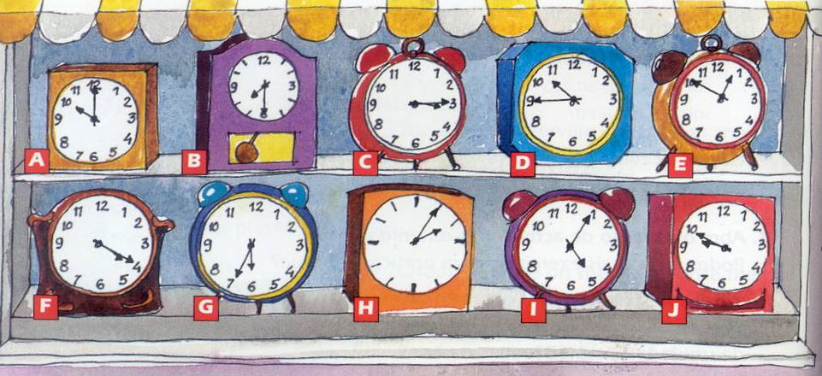

A |  | It’s ten o’clock.
B
C
D
E
F
G
H
I
J

