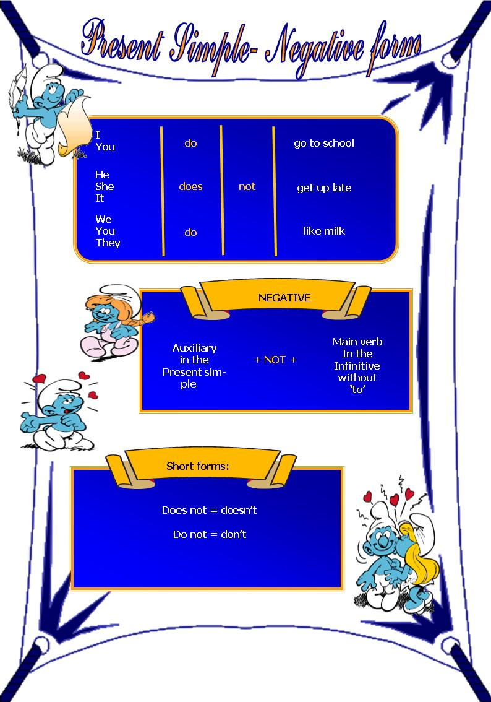

- Read at the following affirmative sentences. Then put them in the negative form.

- Mark gets up late.
- _______________________________________
- Mary cleans her bedroom.
- _______________________________________
- Susan sleeps until twelve o’clock on Sundays.
- _______________________________________
- They go to the cinema.
- _______________________________________
- I know the way to your house.
- _______________________________________

- Look at the sentences bellow. Write them in the negative form following the example.
E.g. I like ice-cream. - I don’t like ice-cream.
- We play football. ________________________________
- They eat Italian food. ____________________________
- You drink milk. __________________________________
- I clean my bedroom. _____________________________

E.g. She likes ice-cream – She doesn’t like ice-cream.
- He plays football. ________________________________
- He drinks coke. _________________________________
- The cat eats fish. ________________________________
- She washes her hair. _____________________________

- Rewrite the following sentences in the negative form.

- Susan’s mother cooks dinner. _______________________________
- The children watch TV. ____________________________________
- Susan goes to school by bus. _______________________________
- Their parents go shopping. _________________________________

