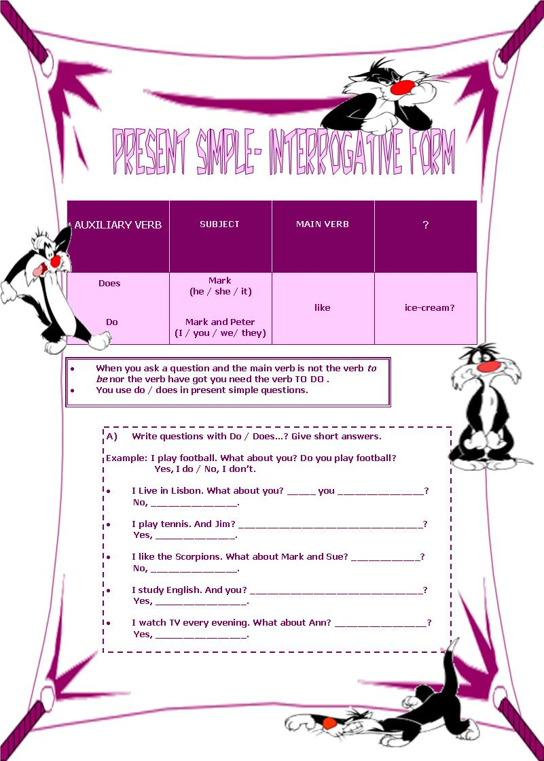

B) Use the verbs in brackets to complete the questions:

- Where ___________ she ___________? (live)
- ___________you ___________ where I live? (know)
- What ___________ Mark ___________ for lunch? (have)
- ___________she ___________ French? (speak)
- When ___________ we ___________? (get up)
- ___________ Peter ___________ sports? (like)
- Why ___________ she ___________ so much? (study)
- How long ___________ you ___________ to get to school? ( take)

C) Complete the questions:

- What time ___________________________________________________?
I go to school at 8:30.

- Where ______________________________________________________?
My father works in Lisbon.

- ____________________________________________________________?
Yes, Mary speaks English very well.

- ____________________________________________________________?
No, I don’t like milk.

- How ________________________________________________________?
I go to school by bus.

D) Ask questions:

- __________________________________________________________?
Yes, I like ice-cream.

- __________________________________________________________?
No, Mark doesn’t speak French.

- __________________________________________________________?
Yes, She arrives at 8 o’clock.

