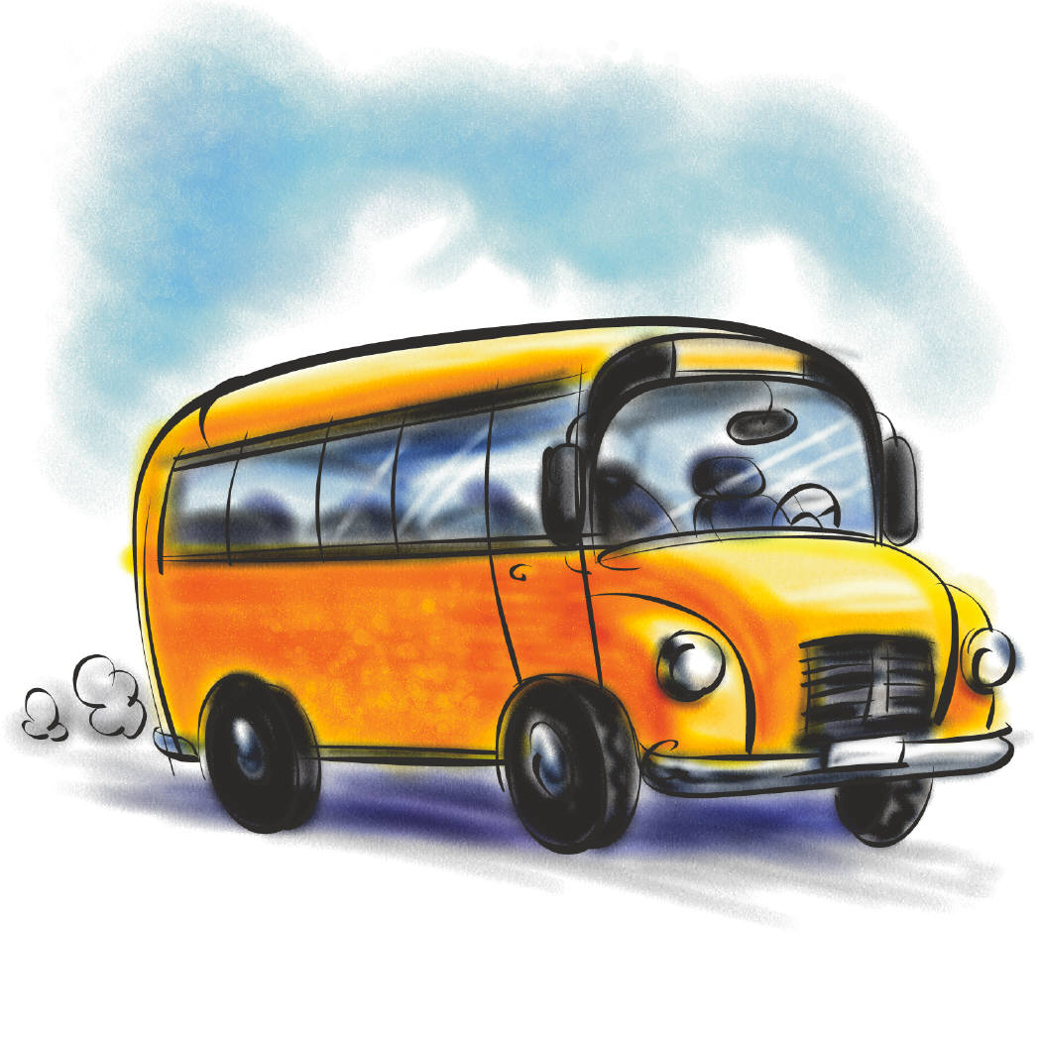
Daily Routine


SCHOOL

get up have a shower have breakfast go to school have lunch


play do the homework watch TV have dinner go to bed

Daily Routine


SCHOOL

get up have a shower have breakfast go to school have lunch


play do the homework watch TV have dinner go to bed

Daily Routine


SCHOOL

get up have a shower have breakfast go to school have lunch


play do the homework watch TV have dinner go to bed

