
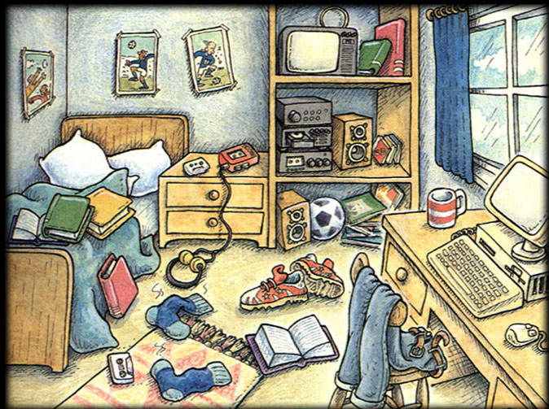
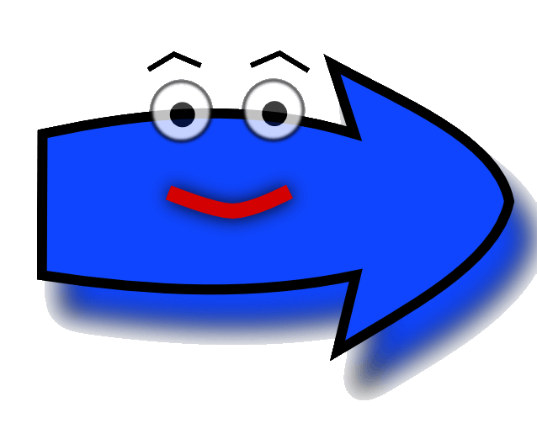
Prepositions of place
PUT THE RIGHT PREPOSITION

- The socks are …………..the carpet.
- The ball is…………….the stereo.
- The TV is …………….the stereo.
- The posters are………………..the bed.
- The posters are………………….the wall.
- The book is ……………the desk ad the socks.
- The nightstand is …………………the bed and the bookshelf.
- ………………….., there is a computer.
- On………………….., there is a bed.
- The cup is………………..the computer.
- The chair is………………..the table.
- The notebook is…………….the green book.
- There is a pillow ………………………….of the bed.
- There are some books……………..the book shelf.
ON
IN
UNDER
NEAR
NEXT TO
BEHIND
ABOVE
IN FRONT OF
BETWEEN
IN THE CORNER
ON THE LEFT
ON THE RIGHT

TRUE/FALSE
- The computer is under the desk.
- The chair is under the jeans.
- The socks are on the carpet.
- The stereo is on the TV.
- The headphones are between the boots and the bed.
- The blanket is under the books.
- The curtains are behind the window.
- The porters are near the computer.

PRACTICE:
NEW WORDS:

