Grammar:
Prepositions of Place

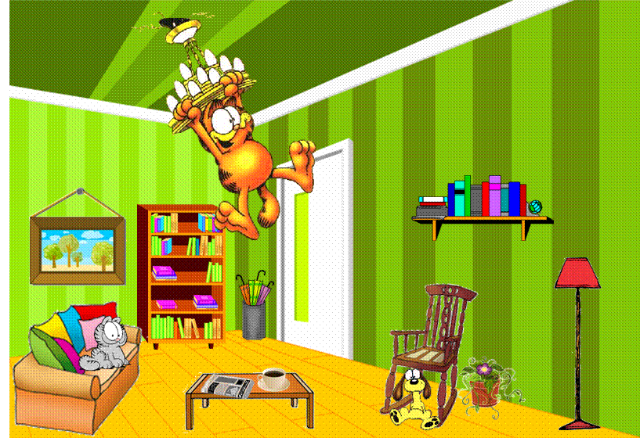
Look at Jon’s living room.

A. Insert the missing vowels and find some PREPOSITIONS OF PLACE.

- ___ pp ___ s ___ t ___
- b ___ tw___ ___ n
- ___ nd ___ r
- ___ b ___ v___
- b ___ h ___ nd
- ___ n
- b ___ l ___ w
- n ___ xt t___
- n ___ ___ r
- ___ n fr___ nt ___f

B. Complete the sentences using PREPOSITIONS OF PLACE from exercise A.

1. Garfield is hanging _______________ the ceiling.
2. Odie is sitting _______________ the rocking chair.
3. Nermal is sitting _______________ the sofa.
4. The bookcase is _______________ the painting and the umbrella stand.
5. The sofa is _______________ the coffee table.

6. The cushions are _______________ Nermal.
7. The shelf is _______________ the rocking chair and the plant.
8. The red lamp is _______________ the rocking chair.
9. The cup of coffee is _______________ the newspaper.
10. Nermal is _______________ the cushions.
11. The coffee table is _______________ Garfield.

