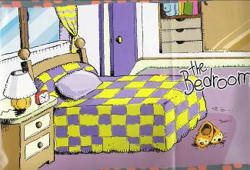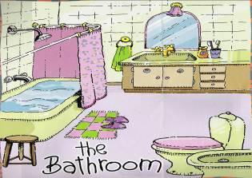
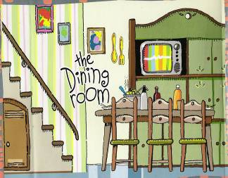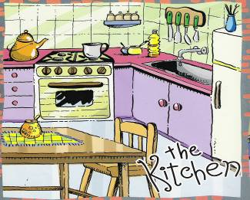
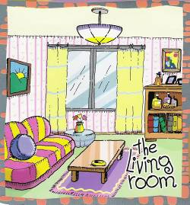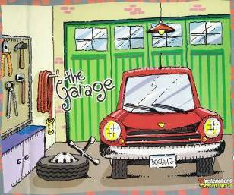
Welcome!!
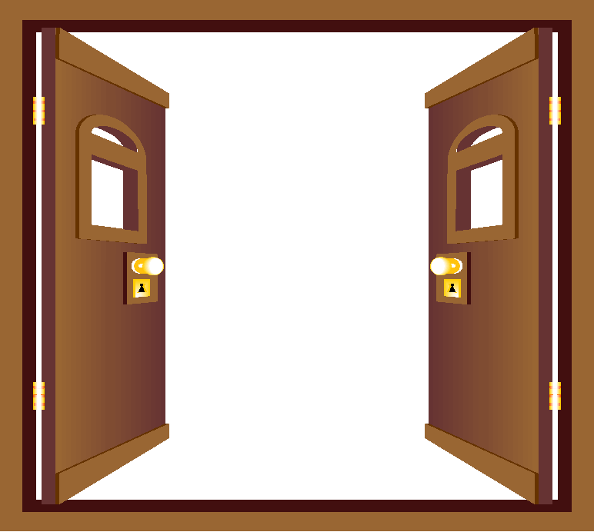

Label the furniture and write them here
Bedroom:..........................................................
Bathroom:.........................................................
Living room:......................................................
Dining room:....................................................
Kitchen:........................................................
Garage:............................................................

Look at the picture and complete the sentences
1-There is a clock in the.................................
2-There is a car in the ....................................
3-There is a bookshelf in the ...................................
4-There are three chairs in the.....................................
5-There is a bath in the..............................................
6-There is a fridge in the.............................................

Answer the questions
1-Is there a big window in the bedroom?................................................................
2-Are there four chairs in the kitchen?................................................................
3-Is there cupboard in the dining room?................................................................
4-Is there a clock in the living room?..................................................................
5-Are there two cars in the garage?................................................................



