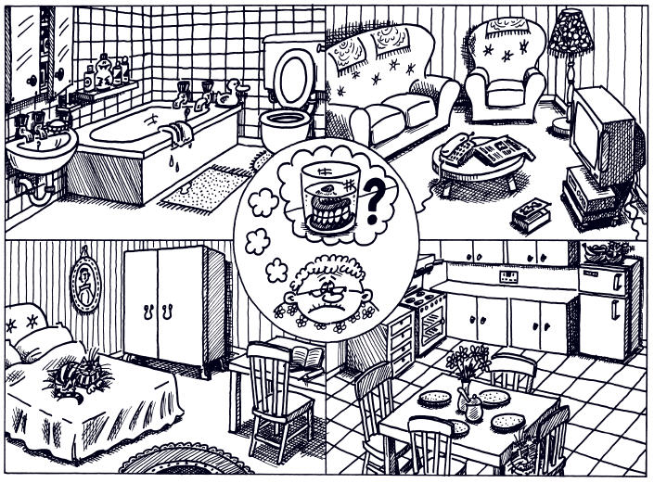

Verb there to be (haver)
. Só tem duas formas, uma para o singular e outra para o plural:
Ex. There is a cat in the bedroom.
There are four plates in the kitchen.

How many (quantos/quantas)
. Serve para perguntarmos sobre a quantidade de pessoas, coisas ou animais.
Ex. How many telephones are there?
……………………..……………………..…………………….……………………..………………………………….

1. Using the vocabulary given, ask and answer following the model:
Model:

Verb there to be (haver)
. Só tem duas formas, uma para o singular e outra para o plural:
Ex. There is a cat in the bedroom.
There are four plates in the kitchen.

How many (quantos/quantas)
. Serve para perguntarmos sobre a quantidade de pessoas, coisas ou animais.
Ex. How many telephones are there?
……………………..……………………..…………………….……………………..………………………………….

1. Using the vocabulary given, ask and answer following the model:
Model:

- How many toilets are there in the bathroom?
- There is one toilet.
- How many toilets are there in the bathroom?
- There is one toilet.

Vocabulary: bathroom / bedroom / kitchen / living room
bed / cooker / armchair / toilet / washbasin / ball
chair / bird / carpet / wardrobe / television

1.1. How many ________________________________________?
There ______________________________________________.
1.2. _______________________________________________?
___________________________________________________.
1.3. _______________________________________________?
___________________________________________________.
1.4. _______________________________________________?
___________________________________________________.
1.5. _______________________________________________?
___________________________________________________.
1.6. _______________________________________________?
___________________________________________________.
1.7. _______________________________________________?
___________________________________________________.
1.8. _______________________________________________?
___________________________________________________.
1.9. _______________________________________________?
___________________________________________________.
1.10. _______________________________________________?
___________________________________________________.

Vocabulary: bathroom / bedroom / kitchen / living room
bed / cooker / armchair / toilet / washbasin / ball
chair / bird / carpet / wardrobe / television

1.1. How many ________________________________________?
There ______________________________________________.
1.2. _______________________________________________?
___________________________________________________.
1.3. _______________________________________________?
___________________________________________________.
1.4. _______________________________________________?
___________________________________________________.
1.5. _______________________________________________?
___________________________________________________.
1.6. _______________________________________________?
___________________________________________________.
1.7. _______________________________________________?
___________________________________________________.
1.8. _______________________________________________?
___________________________________________________.
1.9. _______________________________________________?
___________________________________________________.
1.10. _______________________________________________?
___________________________________________________.

