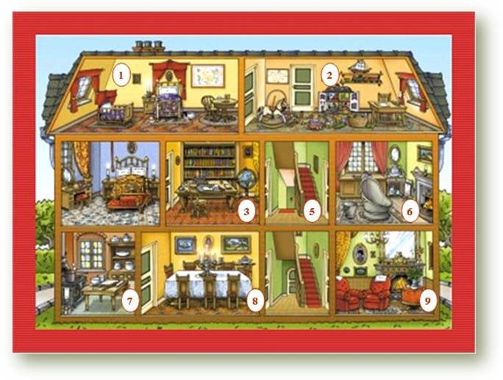
- Look at the picture and write the name of the rooms.
1.__________________ 2. __________________ 3. ___________________
4. __________________ 5. __________________ 6. __________________
7. __________________ 8. __________________ 9. __________________

- Answer the following questions about the picture.

- How many rooms are downstairs? ____________________________
- Is there a kitchen upstairs? _________________________________
- Is there a dining room downstairs? ___________________________
- Are there two bathrooms in the house? _______________________
- Is there a kitchen downstairs? ______________________________
- Where is the living room? __________________________________
- Draw the plan of your house/flat.
  - Name the rooms
  - Draw these things in the right room.
- Fridge
- Lamp
- Table
- Wardrobe
- Sofa
- Rug
- TV set
- Bed
- Picture
- Cooker
- Sink
- Bedside table
- Desk
- Telephone
- Cupboard
- Book case
- Chest of drawers
- Chair
- Shower
- Toilet.

  - Describe your house. Start like this: In my house / flat there is/are…. rooms: the ……
_________________________________________________________________________________________________________________________________________________________________________________________________________________________________________________________________________________________________________________________________________________________________________________________________

- Now ask you partner about his/her house.
Example: Is there / are there a/ an ……………… in your house/ downstairs/ in the bedroom………?
  - Write your questions and his/her answers.
_________________________________________________________________________________________________________________________________________________________________________________________________________________________________________________________________________________________________________________________________________________________________________________________________

