

Name: …………………………………….. Date: ……/……/……

Class : ………… Number: ……….. Evaluation: ………….

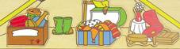
MY HOUSE

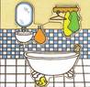
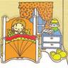
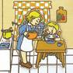
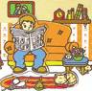
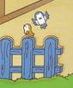
1. Unscramble the words and match:

- attic
a) titca
b) hkcitne
c) hoamrobt
d) dgrnae
e) oomerbd
f) oomr- ningdi
- ………………
- ………………
- ………………
- ………………
- ………………

2. Where is/are …..? Complete the sentences:

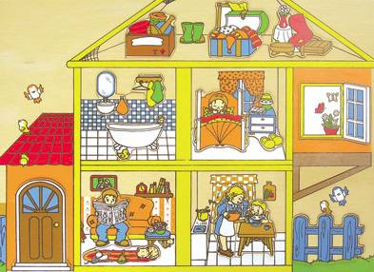
- Where is the father?
He is in the dinning-room.

- Where is the girl?
………………………………………........

- Where are the birds?
Roof
………………………………………………..
Windoww
- Where is the mother?
………………………………………………

- Where are the clothes?
……………………………………………….

- Where is the bathtub?
……………………………………………..
Door
Fence

