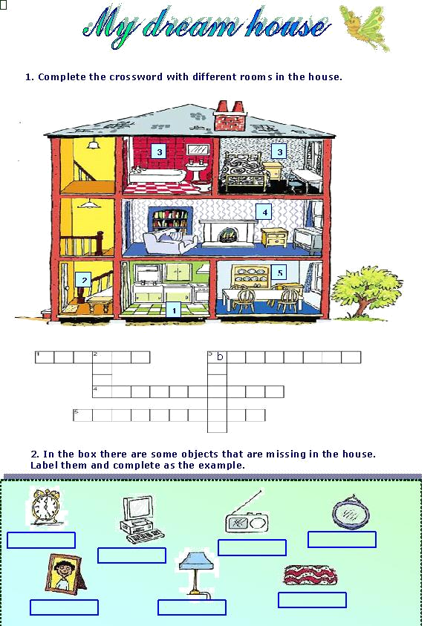
Object
Room in the house
Place
ex. It’s a lamp
____________________________________________________________________________________
ex. Bedroom
______________
_____________________________________________________________________________________
ex. on the bedside table
______________________________________________________________________________________________________________________________

3. Imagine you are an architect. Draw your dream house. Before you draw it organise your ideas in this chart.

Rooms | Bathrooms | Living rooms | kitchen | other


4. Now describe your house. Start like this:

In my house, there are ….. bedrooms ____________________________________________________________
________________________________________________________________________________________________________________________
________________________________________________________________________________________________________________________________________________________________________________________________________________________________________________

