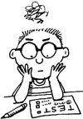

Name: …………………………………….. Date: ……/……/……

Class : ………… Number: ……….. Evaluation: ………….

Put the missing words in the correct compartment of the house.
Armchair
Chest of drawers
Dishwasher
Wash-basin
Photograph
Table
Bathtub
Computer
Cupboard
Fridge
Shower
TV set
Bookcase
Cooker
Curtains
Kettle
Sink
Wardrobe
Chair
Mirror
Sofá
Lamp

