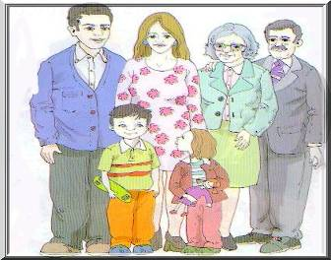
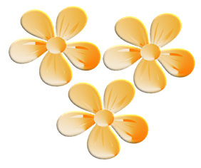
VERB TO BE
Full forms

I am
You are
He is
She is
It is
We are
You are
They are
Contractions

I’m
You're
He’s
She’s
It's
We’re
You're
They’re

- Answer these questions:

- Who is Helen?

- Who is the boy?

- Who is the kind woman?

- Who is the man on the left?



Hi, I’m Carl and this is my family.
The boy is John. He’s my brother.
The girl is Helen. She is my sister
They are my father and mother.
That kind woman is my grandmother and he is my grandfather.

C) Rewrite the following sentences. Use contractions:

- I am from England.

- He is fourteen.

- You are American.

- We are friends.

- She is beautiful.

- You are married.

- They are teachers.

- It is cold.

B) Complete the following sentences:

- Your mother’s mother is your _________
- Your sister's brother is your _________
- Your mother’s father is your _________
- Your mother’s daughter is your _______
- Your mother’s husband is your ________

D) Complete the sentences with are, is or am.

- I _______ interested in football.
- It ______ warm today.
- I _______ hungry.
- Lisbon _____ in Portugal.
- Cats ______ small.
- Susan _____ my teacher.
- We ______ students.
- Mark _____ American.
- You ______ all right.
- Susan and John _____ tourists.
- She _____ fourteen.
- It _____ half past two.
- My name _____ Ann.

E ) Draw a picture of your family and write about them.



