What are they like?

Write sentences describing the people in the picture. There are words in the box to help you.
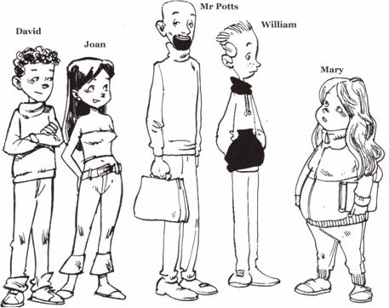
long short fair dark curly wavy bald tall
short well-built slim thin fat beard moustache

Mr Potts _________________________________________________
________________________________________________________
Joan ____________________________________________________
________________________________________________________
Mary ____________________________________________________
________________________________________________________
William __________________________________________________
________________________________________________________
David ___________________________________________________
________________________________________________________

