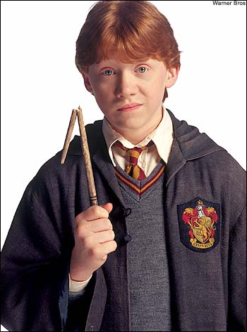

Name:_____________________________

Class:________ N.º___

1. Label the picture .

2.Match.

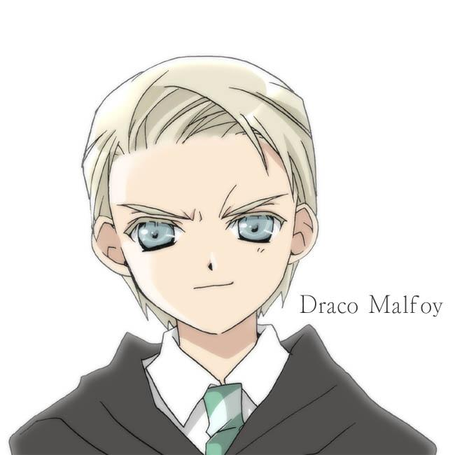
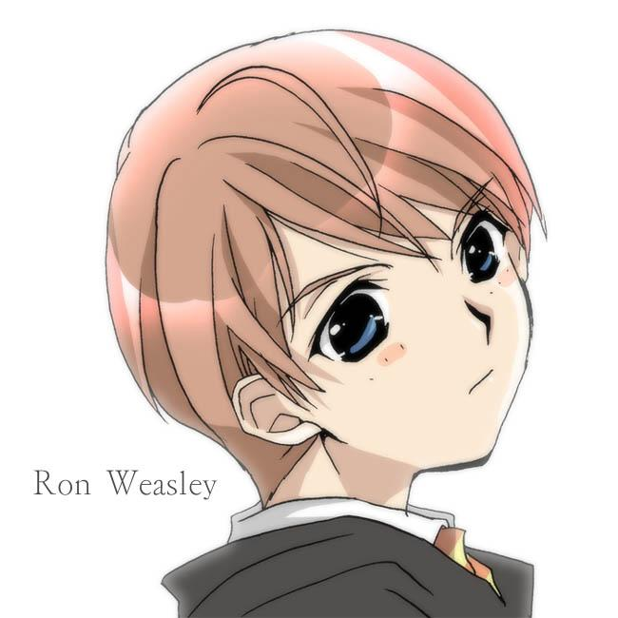
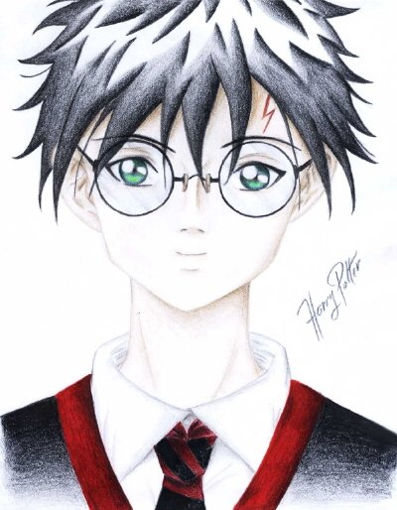
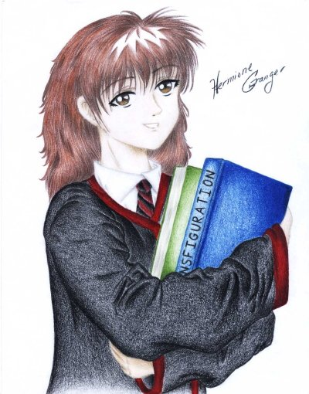

Blond hair
Blue eyes
Red hair
Blue eyes
Dark hair
Green eyes
Brown hair
Brown eyes

1.

4.

3.

2.

3. Draw the pictures according to the instructions.

Long red hair
Blue eyes
Curly dark hair
Brown eyes
Wavy blond hair
Green eyes

4.Complete the texts:
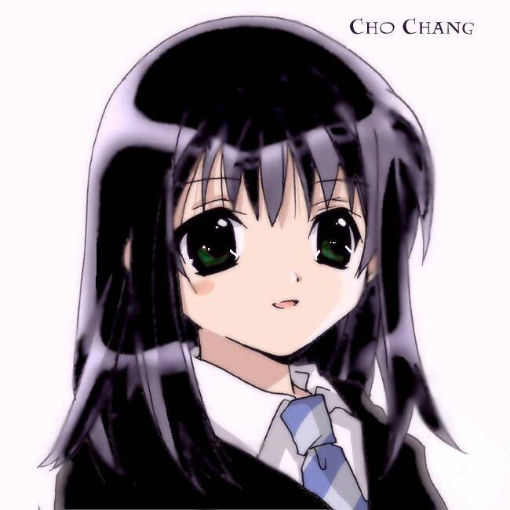
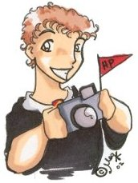
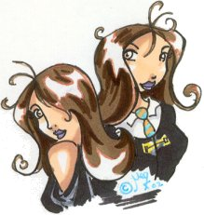
Colin
Parvati twins

Cho Chang

She _____ got _____ dark _______ and green ________.
He______ got ______ red ______ and brown _________.
They ______ got _______ brown ________ and brown ________.

5. Match the words with the pictures.
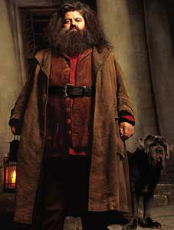

medium height
Hagrid
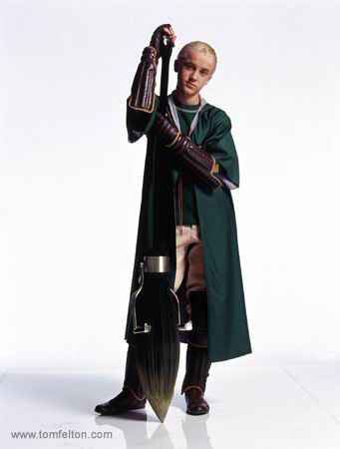
long brown hair
Draco
fat
short blond hair

beard
tall
blue eyes

thin
brown eyes

6. Describe the pictures.

6.1. Draco is ___________________ and __________________. He ______ got __________ ________________ _______________and ______________ _______________.

6.2. Hagrid is ___________________ and ______________________. He ____________ got ________________ __________________ _______________, ______________ __________ and a __________________.

7. Describe yourself.

____________________________________________________________________________________________________________________________________________________________________________________________________________________________________________________________________________________________________________________

