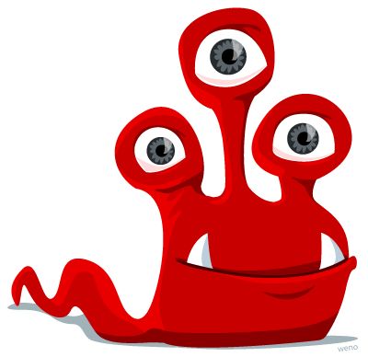
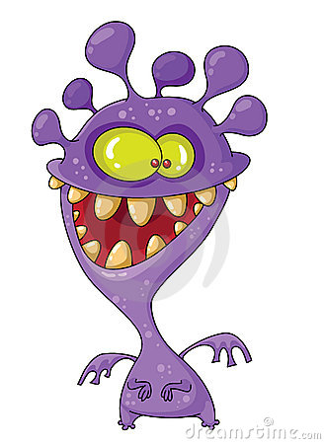
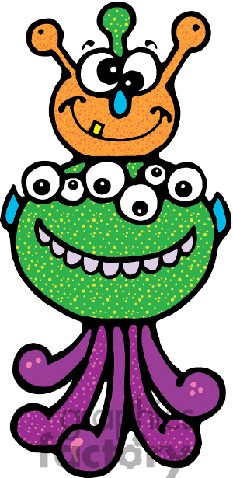
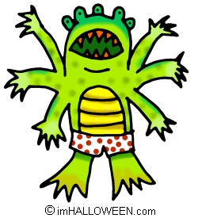
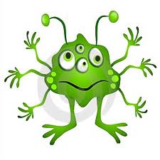
My monsters

It is green. It has got one head, four eyes, one mouth, six arms, twenty fingers, two legs, two feet and six toes.
It _____ brown, green and purple. It ______ got ______ heads, _______ eyes, _________ ears, ______ nose,_____________ mouths __________ teeth, __________ legs and _________ feet.
Complete the sentences about these monsters. Follow the example.
It _____ purple. It ______ got _________ head, ________ yellow eyes, ____________ ears, __________ ,mouth, ____________ teeth, __________ arms, _______ hands, _________ wings, ______legs and ________ feet.
It _____ yellow and green. It ______ got ______ head, _______ eyes , __________ mouth, _________ teeth, _________ arms, ____________ fingers, __________ legs, _________ feet and _____________ toes.

