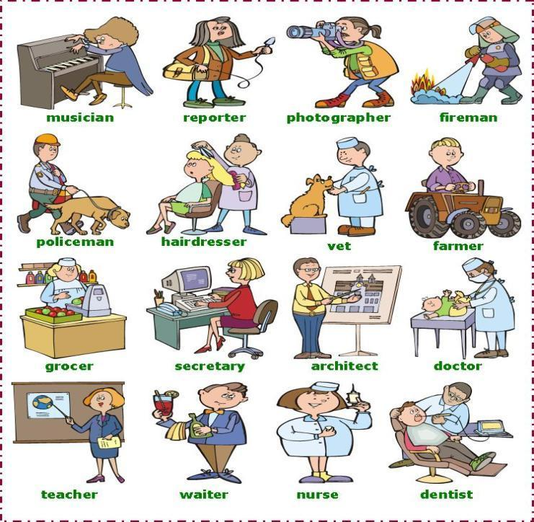
JOBS / PROFESSIONS

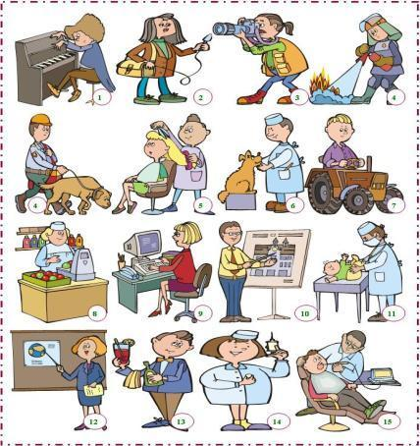
Example (teacher / nurse) – Is she a teacher? _ No she isn´t. she is a nurse.
- (engineer / farmer) - _______________________? No, _________________. He ____________________.
- ( teachers / doctors) - ______________________? No, _________________. They __________________.
- ( nurse / student) - ________________________? No, _________________. I´______________________.
- (musician/ secretary) - _____________________? No, _________________. She ____________________.
- ( hairdresser / vet) - _______________________? NO, ________________. We _____________________.

C) Make questions and complete the answers:
Example: 1. Is he a doctor? _ No He isn´t. He is a musician.
2. Is she a singer? __________________________________
3. Is he a photographer? ____________________________
4. Is he a farmer? __________________________________
5. Is he a dentist? __________________________________
6. Is he a nurse? ___________________________________
7. Is he a farmer? __________________________________
8. Is he a teacher? _________________________________

Example: She is a nurse.

- He _____ ______ student.
- You _____ ______ architect.
- She _____ ______ electrician.
- Mark _____ ______ mechanic.
- She _____ ______musician.
- They _____ ______ teacher.
- I _____ ______ nurse.
- It _____ ______ school.
- We _____ ______ dentists.
- You _____ ______ farmer.
- ________________________
- ________________________
- ________________________
- ________________________
- ________________________
- ________________________
- ________________________
- ________________________
- ________________________
- ________________________
- ________________________
- ________________________
- ________________________
- ________________________
- ________________________

- What are these people jobs?
Label the pictures.
C) Look at the pictures and answer the following questions:
B) Fill in the gaps with the indefinite articles a or an and the correct form of verb to be.

