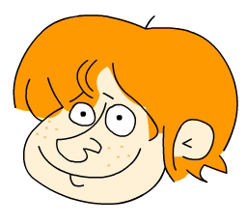
Fill in with is or has.
Complete with forms of to be or to have.

Betty _____ thirty and she _____ English.
She _____ a very nice person.
She _____ got long hair.
Her face _____ round
and her nose _____
very small. She _____
got brown eyes. She
_____ short and a bit
fat. That _____ why
she _____ gym lessons
three times a week.
I ______ got many friends at school but my best friend ______ Brian Carter. We ______ the same hobbies and we ______ a good time together. Brian’s
hair ______ curly and dark,
my hair ______ wavy and
fair; his eyes ______ black
but I ______ got blue eyes.
We ______ both short and
slim. He ______ a good sense of
humour and I ______ funny. He
_____ stubborn I _____ bossy.

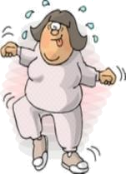
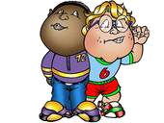

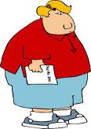
Circle the suitable adjective.


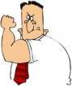
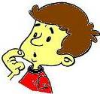

- fat
- slim
- thin
- lovely
- pretty
- ugly
- confident
- curious
- shy
- sensitive
- strong
- weak
- middle- aged
- old
- young

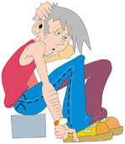

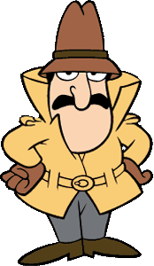

- beautiful
- horrible
- nice
- funny
- sad
- unhappy
- busy
- hardworking
- lazy
- clever
- friendly
- strict
- plump
- short
- tall

Order the words.
- girl/tall/a/is/she/./
__________________________________
- is/./he/and/young/thin/
__________________________________
- fair/got/./they/ hair/have/
__________________________________
4. like/ he/?/what/is/
__________________________________
5. your/are/?/brown/eyes/
__________________________________
6. father/moustache/her/a/got/big/has/./
__________________________________

Fill in with is or has.
Complete with forms of to be or to have.
Betty is thirty and she is English. She is a very nice person. She has got long hair. Her face is round and her nose is very small. She has got brown eyes. She is short and a bit fat. That is why she has gym lessons three times a week.
I have got many friends at school but my best friend is Brian Carter. We have the same hobbies and we have a good time together. Brian’s hair is curly and dark, my hair is wavy and fair; his eyes are black but I have got blue eyes. We are both short and slim. He has a good sense of humour and I am funny. He is stubborn I am bossy.

Circle the suitable adjective.
Order the words.
- a
- c
- c
- b
- b
- b
- a
- c
- a
- b
- girl/tall/a/is/she/./
She is a tall girl.
- is/./he/and/young/thin/
He is young and thin.
- fair/got/./they/ hair/have/
They have got fair hair.
4. like/ he/?/what/is/
What is he like?
5. your/are/?/brown/eyes/
Are your eyes brown?
6. father/moustache/her/a/got/big/has/./
Her father has got a big moustache.

